Amazon Bedrock AgentCore Architecture Notes
What is this Architecture?
Amazon Bedrock AgentCore provides all the infrastructure needed to build, deploy, and operate AI agents in production. Your AI agent can be created using any framework (such as LangGraph, CrewAI, AutoGen, or Google ADK), while AgentCore provides the production capabilities like memory, security, runtime, monitoring, and deployment.
Think of it like this:
- Your Agent = The brain that decides what to do.
- AgentCore = The platform that helps the brain work safely, reliably, and at scale.

1. Agent (Any Framework)
The Agent is the intelligent application that interacts with users and performs tasks. It contains the business logic, reasoning process, workflows, and decision-making capabilities.
Amazon Bedrock AgentCore does not require you to use a specific framework. You can build your agent using any framework you prefer and then run it using AgentCore.
Supported Frameworks
- LangGraph
- CrewAI
- OpenAI Agents SDK
- Google Agent Development Kit (ADK)
- Microsoft AutoGen
- Custom Python Frameworks
Responsibilities of the Agent
- Understand user requests
- Plan the next action
- Call LLMs
- Use tools when required
- Read or update memory
- Generate the final response
Example
A Travel Booking Agent receives the request:
"Book me a flight from Delhi to Goa."
The agent decides:
- Search available flights
- Compare prices
- Ask for confirmation
- Book the ticket
The reasoning happens inside the Agent.

2. Build
The Build stage is where you create your AI agent by connecting different AgentCore capabilities.
Building does not simply mean writing Python code. It means assembling everything the agent needs to work in production.
During the build phase you connect:
- Memory
- Runtime
- Identity
- Gateway
- Built-in Tools
- LLMs
- External APIs
Why Build is Important
Without these components, the agent would only be able to generate text. It would not remember users, access APIs, execute tools, or run securely.
Example
When creating a Customer Support Agent, you connect:
- Memory for conversation history
- Identity for user authentication
- Runtime to execute workflows
- Browser tool to search documentation
Now the agent becomes a complete production application.

3. Memory
Memory allows an AI agent to remember information instead of treating every request as a completely new conversation.
Without memory, the agent forgets everything after each response.
With memory, the agent remembers important information and uses it later.
Memory Can Store
- Previous conversations
- User preferences
- User profile
- Goals
- Tasks
- Retrieved documents
- Important facts
Types of Memory
Short-Term Memory
Stores information only during the current conversation.
Example:
User:
"My favorite color is blue."
Later:
"What is my favorite color?"
The agent remembers because the conversation is still active.

Long-Term Memory
Stores information for future conversations.
Example:
Today:
"My preferred language is English."
Next week:
The agent still remembers this preference.

Working Memory
Stores temporary information while performing a task.
Example:
While booking a flight:
- Departure city
- Destination
- Travel date
These values are stored only until the booking is completed.

4. Built-in Tools
Large Language Models can generate text, but they cannot directly perform real-world actions.
Tools give the agent additional capabilities.
AgentCore provides built-in tools that agents can use whenever required.
Examples include:
- Code Interpreter
- Browser
- File Processing
- API Calls

Code Interpreter
The Code Interpreter allows the agent to execute Python code.
It is useful for:
- Data analysis
- Mathematical calculations
- CSV processing
- Graph generation
- Statistical operations
Example
User uploads a CSV file and asks:
"Show monthly sales."
The Code Interpreter:
- Reads the CSV
- Calculates totals
- Creates charts
- Returns the result

Browser Tool
The Browser tool allows the agent to search websites and collect live information.
Example
User asks:
"Find today's weather."
The Browser:
- Opens weather websites
- Reads the information
- Sends the result back to the agent
The LLM then creates a natural language response.

5. Gateway
The Gateway is the entry point for all incoming requests.
Every request passes through the Gateway before reaching the agent.
Its primary responsibility is to manage and control traffic.
Gateway Responsibilities
- Route requests
- Validate requests
- Apply rate limits
- Log requests
- Perform load balancing
- Forward requests to the correct agent
Why Gateway is Needed
Without a Gateway:
- Invalid requests may reach the agent.
- Too many users could overload the system.
- Traffic cannot be managed efficiently.
Example
A shopping website receives 20,000 requests every minute.
The Gateway distributes requests across multiple agent instances so that no single server becomes overloaded.

6. Identity
Identity ensures that only authorized users and services can access the agent.
It manages authentication and authorization.
There are two main types:
Inbound Authentication
Verifies users before they access the agent.
Common authentication methods include:
- IAM
- OAuth
- JWT Tokens
- API Keys
Example
Before accessing a Banking Agent, the user logs in.
Only authenticated users can access account information.

Outbound Authentication
Sometimes the agent needs to call external services.
The agent must authenticate itself before accessing those services.
Example
The agent wants to:
- Read Gmail
- Access Salesforce
- Retrieve Jira tickets
Before connecting, it proves its identity using secure credentials.

7. Runtime
Runtime is the environment where the AI agent actually runs.
Writing an agent is different from executing it.
Runtime is responsible for executing every request.
Runtime Responsibilities
- Execute workflows
- Call LLMs
- Invoke tools
- Access memory
- Handle retries
- Manage sessions
- Handle failures
- Allocate resources
Why Runtime is Important
Without Runtime:
The agent is simply source code.
Runtime converts the code into a running application.
Example
User asks:
"Summarize this PDF."
Runtime performs:
- PDF reading
- Text extraction
- LLM call
- Summary generation
- Response delivery

8. Observability
Observability provides complete visibility into everything happening inside the agent.
It helps developers monitor, debug, and improve the system.
Think of it as the monitoring system of the entire platform.
Observability Tracks
- Request logs
- Errors
- Latency
- Tool execution
- Memory usage
- Token usage
- API calls
- Cost
- Workflow execution
Why Observability is Important
If something goes wrong, developers can quickly identify the exact component causing the problem.
Example
Suppose users report slow responses.
Observability shows:
- LLM response time = 8 seconds
- Browser tool = 2 seconds
- Memory lookup = 100 ms
Developers immediately know that the LLM is causing the delay.

9. Deploy
Deployment means making the agent available for real users.
Instead of running on a developer's laptop, the agent is hosted in a production environment where thousands of users can access it.
During Deployment
- Infrastructure is created
- Agent is hosted
- Runtime starts
- Gateway becomes active
- Security is enabled
- Monitoring begins
Example
A company's HR chatbot is deployed on AWS.
Now every employee can use it through the company's internal portal.

10. Assess
Assessment is the process of continuously evaluating the agent after deployment.
Deployment is not the final step.
Developers constantly measure how well the agent performs.
Assessment Includes
- Accuracy
- Hallucination detection
- Response quality
- Response time
- Token usage
- Cost
- Tool success rate
- User satisfaction
Example
Suppose users report incorrect answers.
The team evaluates:
- Which prompts failed?
- Which tool produced incorrect data?
- Was the retrieved context correct?
- Did the LLM hallucinate?
The agent is then improved based on these findings.

Complete Request Flow
Imagine a user asks:
"Book a flight from Delhi to Goa."
The request moves through the following steps:
- The request reaches the Gateway.
- Identity verifies that the user is authenticated.
- Runtime starts executing the agent.
- The agent checks Memory for saved preferences such as preferred airline or seat type.
- The agent uses Built-in Tools or external APIs to search available flights.
- The LLM analyzes the results and prepares the best option.
- Runtime returns the final response to the user.
- Observability records every step, including latency, logs, token usage, and errors.
- Since the agent is already Deployed, real users can access it at any time.
- Over time, the development team Assesses performance and continuously improves the agent.

AgentCore Runtime
Before we start, let's understand some important keywords because they appear many times in this slide.

Keyword 1: What is Runtime?
The word Runtime simply means the place where your application actually runs after you have built it.
Think about writing a Python program.
First, you write the code.
Then you save it.
But nothing happens until you execute it.
The moment Python starts executing your code, your program is running inside a runtime environment.
Exactly the same idea exists for AI agents.
Writing an AI agent is only the first step.
After writing it, you need a place where it can actually receive user requests, call APIs, use tools, remember conversations, generate responses, and continue working.
That place is called the Runtime.
Real-life analogy
Imagine you write a recipe for making pizza.
The recipe itself cannot cook anything.
You need a kitchen.
The kitchen has electricity, gas, oven, utensils, and workers.
The recipe is your AI agent.
The kitchen is the Runtime.
Without the kitchen, the recipe cannot produce pizza.
Without Runtime, your AI agent cannot work.

Keyword 2: What is an AI Agent?
An AI agent is much more than a chatbot.
A chatbot usually answers questions.
An AI agent can think, decide, call tools, execute actions, use APIs, read documents, remember conversations, and complete tasks automatically.
For example,
A travel booking agent can:
- understand your request
- search flights
- compare prices
- book tickets
- send confirmation emails
Instead of only replying with text.

Keyword 3: What is Hosting Environment?
Many beginners think Hosting means only EC2.
That is not true.
A Hosting Environment simply means the place where your application lives and runs.
It includes everything needed to execute your application.
For example,
- CPU
- Memory (RAM)
- Network
- Storage
- Security
- Internet connection
- Operating system
- Logs
- Scaling
When someone sends a request,
the hosting environment provides all these resources so your application can process the request.
AWS offers many hosting environments.
For example:
- EC2
- Lambda
- ECS
- EKS
- AgentCore Runtime
AgentCore Runtime is a hosting environment specially built for AI agents.

1. AgentCore Runtime provides a secure, serverless, purpose-built hosting environment for deploying and running AI agents or tools.
This is the most important sentence on the slide, so let's understand every part.
What is it?
AgentCore Runtime is a managed service from AWS that provides a ready-made environment where your AI agent can live and work.
Instead of creating your own servers, installing software, configuring networking, setting up monitoring, and worrying about security, AWS gives you an environment that is already prepared for AI agents.
Your job is only to build the agent.
AWS handles the platform.

What does "Secure" mean?
Secure means AWS protects your agent from unauthorized access.
It provides features like:
- authentication
- authorization
- IAM permissions
- encrypted communication
- isolated execution
This reduces the chances of someone accessing your agent without permission.

What does "Serverless" mean?
Many beginners misunderstand serverless.
It does not mean there are no servers.
Servers still exist.
The difference is:
You do not manage them.
AWS manages:
- creating servers
- updating them
- patching them
- replacing failed machines
- scaling them
You only deploy your agent.

What does "Purpose-built" mean?
Purpose-built means this environment was specially designed for AI agents.
It already understands things like:
- sessions
- tool execution
- AI workloads
- long-running tasks
- security
- scaling
If you used a normal EC2 machine, you would build all of this yourself.

What does "Deploying" mean?
Deploying means moving your finished application from your laptop into an environment where users can actually use it.
On your laptop, only you can test it.
After deployment, thousands of users can access it.

What does "Running" mean?
Deployment happens once.
Running happens continuously.
After deployment, the Runtime keeps your AI agent alive so it can receive requests every day.

Real Project Example
Suppose your company builds an HR assistant.
Employees ask:
"How many leave days do I have?"
Instead of running this assistant on your laptop, you deploy it into AgentCore Runtime.
Now employees across the company can use it anytime.

2. It handles scaling, session management, security isolation, and infrastructure management.
This point explains why companies like managed services.
Instead of worrying about infrastructure, developers focus on business logic.

Scaling
Scaling means handling more users.
Imagine only five people visit your website.
One server is enough.
Now imagine 50,000 people open it at the same time.
One server becomes overloaded.
Normally you would manually create more servers.
AgentCore Runtime can automatically increase resources when traffic grows and reduce them when traffic becomes low.
This saves both effort and money.

Session Management
A session means remembering one user's conversation while keeping it separate from others.
Suppose:
Rahul asks,
My name is Rahul.
Later he asks,
What is my name?
The agent should remember Rahul.
At the same time,
Priya is chatting separately.
Rahul's information should never appear in Priya's conversation.
Managing these separate conversations is called session management.

Security Isolation
Isolation means keeping one user's execution separate from another.
If one customer's agent crashes or has a security issue, it should not affect other customers.
Think of apartments in one building.
Everyone lives in the same building, but each family has its own locked home.
That separation is isolation.

Infrastructure Management
Infrastructure includes:
- servers
- networking
- storage
- operating systems
- monitoring
- logging
Instead of maintaining all these manually, AWS manages them.

Real Project Example
An online banking assistant may receive thousands of requests every minute.
Developers don't manually create new servers.
AgentCore Runtime automatically scales, manages sessions, and keeps users isolated.

3. It represents a containerized application that processes user inputs, maintains context, and executes actions using AI capabilities.
This sentence explains what actually runs inside AgentCore Runtime.
Your AI agent is packaged as a containerized application.

What is a Container?
A container is a package that contains:
- your Python code
- required libraries
- dependencies
- configuration
- runtime files
Everything travels together.
So the application behaves the same everywhere.
Docker is commonly used to create containers.

Processes User Inputs
When users send messages,
the runtime forwards them to your container.
Your application reads the input.
Example:
User:
Summarize this PDF.
Your application receives this request.

Maintains Context
Context means remembering previous conversation.
Without context:
User:
My name is Suraj.
Later:
What is my name?
The agent forgets.
With context:
The agent remembers your previous messages and answers correctly.

Executes Actions
The agent does more than generate text.
It can:
- call APIs
- query databases
- search documents
- send emails
- invoke Lambda
- use external tools

Practical Implementation
In a FastAPI application:
- User sends request.
- Runtime sends it to your container.
- FastAPI receives it.
- Bedrock model generates reasoning.
- Agent calls required tools.
- Final response returns to user.

4. When you create an agent, you define its behavior, capabilities, and the tools it can access.
Creating an agent is not only about choosing an LLM.
You also decide how it should behave.

Behavior
Behavior defines the personality and rules.
For example:
- Always answer politely.
- Never reveal confidential information.
- Respond only using company documents.
These instructions become part of the agent.

Capabilities
Capabilities define what the agent is able to do.
For example,
Can it:
- summarize?
- search documents?
- answer questions?
- translate?
- generate reports?
These are its capabilities.

Tools
Tools allow the agent to interact with external systems.
Examples include:
- weather API
- SQL database
- Amazon S3
- Bedrock Knowledge Base
- calculator
- email service
Without tools, an LLM only generates text.
With tools, it performs real work.

Real Project Example
A customer support agent may have access to:
- CRM database
- order system
- refund API
- payment service
These tools allow it to solve customer problems automatically.

5. Each Agent Runtime has a unique identity and immutable version for deployment.
Every deployed runtime gets its own identity.
This helps AWS know exactly which runtime is being used.
The important part is immutable version.
Immutable means cannot be changed after creation.
Instead of editing Version 1,
you create Version 2.
This makes deployments safe.
If Version 2 has a bug, you can roll back to Version 1 because it was never modified.

Real Project Example
Version 1 answers customer questions.
Version 2 adds invoice generation.
If Version 2 fails in production, the company immediately switches back to Version 1.

6. Each version contains all necessary configuration needed for execution.
A version is more than just source code.
It also stores the configuration required to run the agent.
Configuration may include:
- environment variables
- model settings
- tool configuration
- memory configuration
- API endpoints
- permissions
- runtime settings
This ensures that whenever Version 1 is deployed, it always behaves exactly the same.
In production, this consistency is very important because developers, testers, and production environments should all run the same configuration.

7. AgentCore Runtime supports long-running operations up to 8 hours in duration.
Many AI tasks finish within a few seconds.
However, some business processes take much longer.
For example:
- analyzing thousands of PDFs
- generating a very large report
- processing hours of audio
- performing large data migrations
- executing complex workflows
Some platforms stop requests after only a few minutes.
AgentCore Runtime allows these long-running jobs to continue for up to 8 hours, making it suitable for enterprise workloads that cannot finish quickly.

8. To run an agent or tool in AgentCore Runtime, you need an AWS Identity and Access Management (IAM) execution role.
Before explaining the sentence, let's understand IAM.
What is IAM?
IAM stands for Identity and Access Management.
It is AWS's permission system.
It decides:
- Who are you?
- What resources can you access?
- What actions are you allowed to perform?

What is an Execution Role?
An execution role is like an identity card that your application carries.
Instead of using your personal AWS account credentials, the agent assumes this role.
The role contains permissions.
For example:
- Read S3 bucket ✅
- Access Bedrock ✅
- Call Lambda ✅
- Delete EC2 ❌
AWS checks these permissions before allowing any action.
This follows the principle of least privilege, where the agent gets only the permissions it truly needs.

Real Project Example
Suppose your AI agent reads company documents stored in Amazon S3 and then calls Amazon Bedrock to generate an answer.
The execution role must have permission to:
- read from S3
- invoke Bedrock
Without those permissions, AWS blocks the request.

9. You can create an agent with AgentCore Runtime using either a Starter Toolkit (CLI-based) or without it using AgentCore, Python SDK, FastAPI, and Docker. (Last words are hidden in the screenshot.)
This point explains that AWS gives you more than one way to build and deploy an agent.
If you are a beginner, you can use the Starter Toolkit, which provides ready-made templates and CLI commands. It reduces setup work and helps you get started quickly.
If you want more flexibility, you can build everything yourself using the Python SDK, create APIs with FastAPI, package the application with Docker, and then deploy it to AgentCore Runtime. This approach is common in production because teams need full control over architecture, dependencies, and deployment pipelines.

How All These Points Connect Together
Think of the complete flow:
- You write an AI agent in Python.
- You decide its behavior, capabilities, and tools.
- You package it as a Docker container.
- You assign an IAM execution role so it has the required AWS permissions.
- You deploy it to AgentCore Runtime.
- AWS runs it in a secure, serverless environment.
- The runtime automatically handles scaling, sessions, security isolation, and infrastructure.
- Users send requests, the agent processes them, remembers context, calls tools if needed, and returns answers.
Everything on this slide is describing different parts of that single lifecycle.

Quick Revision Notes
- AgentCore Runtime is the environment where AI agents actually run.
- It is serverless, so AWS manages the underlying servers for you.
- It provides built-in security, automatic scaling, session management, and infrastructure management.
- AI agents run as containerized applications, typically packaged with Docker.
- The runtime processes user requests, maintains conversation context, and executes actions using AI and external tools.
- When creating an agent, you define its behavior, capabilities, and the tools it is allowed to use.
- Every deployment version is immutable, making updates safer and enabling rollbacks.
- Each version includes all required configuration for consistent execution.
- Long-running AI tasks can execute for up to 8 hours.
- An IAM execution role gives the agent permission to access AWS services securely.

Interview Perspective
Interviewers commonly ask questions such as:
- What is AgentCore Runtime, and why is it needed?
- How is AgentCore Runtime different from running an agent on EC2 or AWS Lambda?
- What does "serverless" mean in this context?
- How does AgentCore Runtime handle scaling automatically?
- What is session management, and why is it important for conversational AI?
- Why are immutable versions useful in production deployments?
- What is an IAM execution role, and why does an agent need one?
- Why are containers (Docker) commonly used to package AI agents?
- Give an example of a long-running AI workload that benefits from AgentCore Runtime.

1. Endpoints
An Endpoint is the address through which your application communicates with the deployed AI agent.
Think about a website.
For example, when you open google.com, your browser knows where to send the request. Similarly, after deploying an AgentCore agent, AWS creates an endpoint so your application knows where to send user requests.
Whenever your frontend (React, Streamlit, mobile app, etc.) wants an answer from the AI agent, it sends the request to this endpoint.

Each endpoint has a unique ARN for referencing a specific agent version.
First understand ARN.
ARN stands for Amazon Resource Name.
AWS gives every resource (EC2, Lambda, S3 bucket, Bedrock Agent, etc.) a unique identity called an ARN.
Think of it like an Aadhaar number.
Many people may have the same name, but everyone's Aadhaar number is different.
Similarly, many agents can exist in AWS, but every endpoint has its own unique ARN.
This ARN helps AWS know exactly which endpoint and which agent version should receive the request.
Example:
Suppose you have released:
- Agent Version 1
- Agent Version 2
- Agent Version 3
Each version can have its own endpoint ARN.
When your application calls the ARN of Version 2, AWS knows it must execute Version 2 only.
This avoids confusion when multiple versions exist.

When you update your Agent, a new version is created; the DEFAULT endpoint automatically updates to reference the latest version.
Imagine your AI chatbot is already running in production.
Today you improve the prompt and add new tools.
Instead of replacing the old version, AWS creates a new version.
For example:
- Version 1 → Initial chatbot
- Version 2 → Added weather tool
- Version 3 → Added database search
AWS never destroys the previous version immediately.
Now comes the DEFAULT endpoint.
The DEFAULT endpoint is like a shortcut.
Instead of remembering Version 1, Version 2, or Version 3, your application simply calls the DEFAULT endpoint.
Whenever a new version is deployed, AWS automatically points the DEFAULT endpoint to the latest version.
This means your frontend does not need any code changes.
Your users automatically start using the newest agent.

Endpoints can be updated without downtime, enabling seamless version transitions and rollbacks.
Downtime means your application becomes unavailable.
For example,
If WhatsApp stops working for 10 minutes during an update, that is downtime.
AgentCore avoids this.
When you deploy a new version, AWS switches users to the new version without stopping the service.
Users continue chatting normally.
If Version 3 contains a bug, AWS can quickly switch the endpoint back to Version 2.
This is called a rollback.
In production systems, rollback is very important because bugs can happen anytime.
Instead of fixing the bug immediately, companies first rollback to the stable version so users are not affected.

2. Sessions
A Session represents one conversation between a user and the AI agent.
Imagine you open ChatGPT.
You ask,
"What is Python?"
Then,
"Who created it?"
Then,
"Explain with an example."
These three questions belong to the same conversation.
That complete conversation is called a Session.
Each user gets their own session so conversations do not mix.

Sessions represent individual interaction contexts between users and AgentCore Runtime.
The word interaction context simply means the conversation history and temporary information needed during that chat.
Suppose two users are chatting.
User A asks:
Tell me about AWS.
User B asks:
Explain FastAPI.
Their conversations should remain separate.
AgentCore creates different sessions so User A never sees User B's conversation.
Each session stores only the temporary information required for that conversation.

Each session is identified by a unique runtimeSessionId provided by your application or the Runtime.
Every session has its own unique ID.
This ID is called runtimeSessionId.
Think of it as a ticket number.
When a user sends another message, the application includes the same session ID.
AgentCore immediately understands,
"This message belongs to the previous conversation."
Without the session ID, every message would look like a brand-new conversation.

Runs in a dedicated microVM with isolated CPU, memory, and filesystem resources.
This is one of the most important concepts.
First understand microVM.
A microVM is a very small virtual machine.
AWS creates a tiny, secure computer only for your session.
Inside that microVM, your AI agent runs.
This microVM has:
- Its own CPU
- Its own Memory (RAM)
- Its own File System
Because everything is isolated, one user's session cannot access another user's data.
This provides strong security and prevents interference between users.
You can imagine a hotel.
Every guest gets a separate room.
Guests cannot access each other's rooms.
Similarly, every session gets its own isolated microVM.

After termination, the microVM is destroyed and memory is sanitized.
When the conversation finishes, AgentCore no longer needs that microVM.
AWS destroys it completely.
Not only is the virtual machine deleted, but its memory is also cleaned.
This process is called memory sanitization.
Why is this important?
Suppose User A discussed confidential company data.
If AWS reused the same memory without cleaning it, another user might accidentally access old data.
Memory sanitization removes all leftover information.
This improves security and privacy.

Ephemeral state: Sessions are short-lived; for long-term context, use Amazon Bedrock AgentCore Memory.
The word Ephemeral means temporary.
A session is not permanent.
It exists only while the conversation is active.
After some time, it ends.
Therefore, sessions should not be used to store long-term user information.
For example,
Suppose today the user says,
My favorite language is Python.
Tomorrow the session is gone.
The runtime no longer remembers this.
If you want the agent to remember information across many days or weeks, you should use Amazon Bedrock AgentCore Memory.
That service stores long-term user context separately from the runtime session.

3. Protocol Support
A protocol is simply a set of communication rules.
It defines how two systems exchange information.
AgentCore Runtime supports two communication protocols.

HTTP: Simple request/response patterns on port 8080.
HTTP is the standard protocol used by websites and REST APIs.
The flow is very simple.
Your application sends one request.
The server processes it.
The server sends one response.
Example:
User

↓

Frontend

↓

HTTP Request

↓

AgentCore Runtime

↓

AI Response

↓

Frontend

↓

User
The slide says HTTP runs on port 8080.
A port is simply a communication door on a computer.
Port 8080 is the door through which HTTP requests enter AgentCore Runtime.

MCP: Standardized agent-tool interactions on port 8000.
MCP stands for Model Context Protocol.
It is a standard protocol that allows AI agents to communicate with external tools in a consistent way.
Instead of every tool using a different format, MCP defines one common language.
For example, suppose your agent needs to use:
- Calculator
- Database
- Gmail
- Slack
- GitHub
- File System
Without MCP, every tool would require a different integration.
With MCP, they all follow the same communication standard.
This makes tool integration much easier and more reliable.
The slide mentions port 8000, meaning MCP communication is handled through that port.

How Everything Works Together (Complete Flow)
Imagine a user asks:
"Find the latest sales report and summarize it."
The complete flow looks like this:
- The frontend sends the request to the AgentCore Endpoint.
- The endpoint identifies which agent version should handle the request.
- AgentCore creates or resumes the user's Session using the runtimeSessionId.
- A secure microVM is started for that session.
- The AI agent runs inside the microVM.
- If the agent needs external tools (such as a database or GitHub), it can communicate using MCP. If it's a normal API request, it uses HTTP.
- The agent generates the response and sends it back to the user.
- When the session ends, the microVM is destroyed, and its memory is sanitized to ensure no data remains.
- If the conversation needs long-term memory (for example, remembering user preferences across days), that information is stored in AgentCore Memory, not in the runtime session.

Quick Revision Notes
- AgentCore Runtime is the execution environment where your deployed AI agent runs.
- An Endpoint is the address your application uses to communicate with the agent.
- Every endpoint has a unique ARN, which uniquely identifies a specific agent version.
- The DEFAULT endpoint automatically points to the latest deployed version.
- Zero downtime updates let you deploy or roll back versions without interrupting users.
- A Session represents one user's conversation with the agent.
- Each session has a unique runtimeSessionId to keep conversations separate.
- Every session runs inside its own isolated microVM with dedicated CPU, memory, and file system resources.
- When the session ends, the microVM is destroyed and its memory is cleaned (sanitized) for security.
- Sessions are temporary (ephemeral). For long-term memory across conversations, use Amazon Bedrock AgentCore Memory.
- AgentCore supports HTTP (port 8080) for normal request/response communication and MCP (port 8000) for standardized communication between AI agents and external tools.

Step 1

app = BedrockAgentCoreApp()

↓

Local Object Bana

────────────────────────────

Step 2

@app.entrypoint

↓

Entry Point Register Hua

────────────────────────────

Step 3

app.run()

↓

Local Testing

────────────────────────────

Step 4

agentcore deploy

↓

Starter Toolkit AWS API Call Karta Hai

↓

AWS Agent Banata Hai

↓

Runtime Ready Hota Hai

↓

Users Request Bhej Sakte Hain

Ek analogy
Socho tum restaurant khol rahe ho.
Tum likhte ho
Restaurant()
Kya customer aa gaye?
❌ Nahi.
Kya waiter aa gaya?
❌ Nahi.
Kya kitchen chalne laga?
❌ Nahi.
Sirf restaurant ka plan bana.

Fir tum bolte ho
Open Restaurant
Ab
- Waiter aaya
- Kitchen chalu hua
- Customer aa sakte hain
Exactly yehi difference hai:
- BedrockAgentCoreApp() = Restaurant ka structure banana.
- agentcore deploy = Restaurant ko public ke liye open karna.

⭐ Final Rule (100% yaad rakho)
Action | Kya hota hai?
app = BedrockAgentCoreApp() | ✅ Local application object banta hai
@app.entrypoint | ✅ Main handler register hota hai
app.run() | ✅ Local testing hoti hai
agentcore deploy | ✅ Starter Toolkit AWS ko deploy request bhejta hai
AWS Deployment Complete | ✅ AgentCore Runtime tumhare deployed agent ko execute karta hai
Isliye Runtime BedrockAgentCoreApp() se create nahi hota. Runtime deployment (agentcore deploy) ke baad AWS ki managed infrastructure ka hissa ban kar tumhare agent ko execute karta hai.
Step 1 app = BedrockAgentCoreApp() ↓ Local Object Bana ──────────────────────────── Step 2 @app.entrypoint ↓ Entry Point Register Hua ──────────────────────────── Step 3 app.run() ↓ Local Testing ──────────────────────────── Step 4 agentcore deploy ↓ Starter Toolkit AWS API Call Karta Hai ↓ AWS Agent Banata Hai ↓ Runtime Ready Hota Hai ↓ Users Request Bhej Sakte Hain yha par policies kha check ho rhi h?
🔥 Excellent question! Ab tum AWS IAM ka actual flow samajhne wale ho.
Tumne timeline sahi likhi. Ab usme IAM Policy checks add karte hain.

Step 1
app = BedrockAgentCoreApp()
Policy check?
❌ Nahi.
Kyun?
Ye sirf tumhare EC2 me ek Python object bana hai.
AWS ko abhi pata bhi nahi ki tumne object banaya hai.

Step 2
@app.entrypoint
def invoke():
Policy check?
❌ Nahi.
Ye bhi local code hai.

Step 3
app.run()
Policy check?
❌ Normally nahi.
Ye local testing hai.
Abhi AWS API call nahi hui.

Step 4 (Yahin sab hota hai)
Tum chalate ho
agentcore deploy
Ab pehli baar AWS ko request jaati hai.
Flow dekho:
Developer
│
▼
agentcore deploy
│
▼
Starter Toolkit
│
▼
AWS API
Ab AWS sabse pehle ye dekhta hai:
Ye request kisne bheji?
Answer:
MyAgentCoreUser
Kaise pata?
Kyuki tumne
aws configure
kiya tha.
Aur usme Access Key di thi.

Step 5 - IAM Authentication
AWS Access Key dekhta hai.
AKIAxxxxxxxx

↓

Belongs to

↓

MyAgentCoreUser

Step 6 - IAM Authorization (Yahi Policy Check hai)
AWS bolta hai
MyAgentCoreUser

↓

Policies Check
Uske paas kya attached hai?
AmazonBedrockFullAccess ✅

CloudWatchFullAccess ✅

MyAgentCoreUserPolicy ✅
Ab AWS check karta hai.
Kya is user ko ye actions allowed hain?
Example
bedrock-agentcore:CreateAgent

Allowed?

↓

YES
iam:PassRole

Allowed?

↓

YES
ecr:CreateRepository

Allowed?

↓

YES
Agar sab allow hain
↓
Deployment continue.

Agar Policy na hoti
Suppose tumhari policy me
bedrock-agentcore:CreateAgent
permission hi nahi hoti.
Flow
agentcore deploy

↓

AWS

↓

Policies Check

↓

❌ Not Allowed

↓

AccessDenied
Agent kabhi create hi nahi hota.

Ab Agent ban gaya
AWS ne Agent create kar diya.
Ab Runtime ready hai.
Ab User request bhejta hai.
User

↓

Runtime

↓

invoke()
Question:
Ab Policy kaun check karega?
Yahan Execution Role aata hai.
Suppose tumhara Agent S3 access karta hai.
Flow
Runtime

↓

Execution Role

↓

Policy Check

↓

s3:GetObject

↓

Allow

↓

Read PDF

Isliye 2 baar Policy Check hoti hai
First Time
Deployment ke waqt
Developer

↓

MyAgentCoreUser

↓

Policies

↓

Agent Create?

Second Time
Runtime ke waqt
Runtime

↓

Execution Role

↓

Policies

↓

S3 Access?

↓

Bedrock Invoke?

↓

CloudWatch?

Complete Production Flow
Developer
│
▼
agentcore deploy
│
▼
MyAgentCoreUser (IAM User)
│
IAM Policies Check
│
▼
Agent Created Successfully
│
▼
AWS AgentCore Runtime Starts
│
User Request Arrives
│
▼
MyAgentCoreExecutionRole
│
IAM Policies Check Again
│
├── S3 Allowed?
├── Bedrock Allowed?
├── Logs Allowed?
└── DynamoDB Allowed?
│
▼
invoke() Executes
│
▼
Response

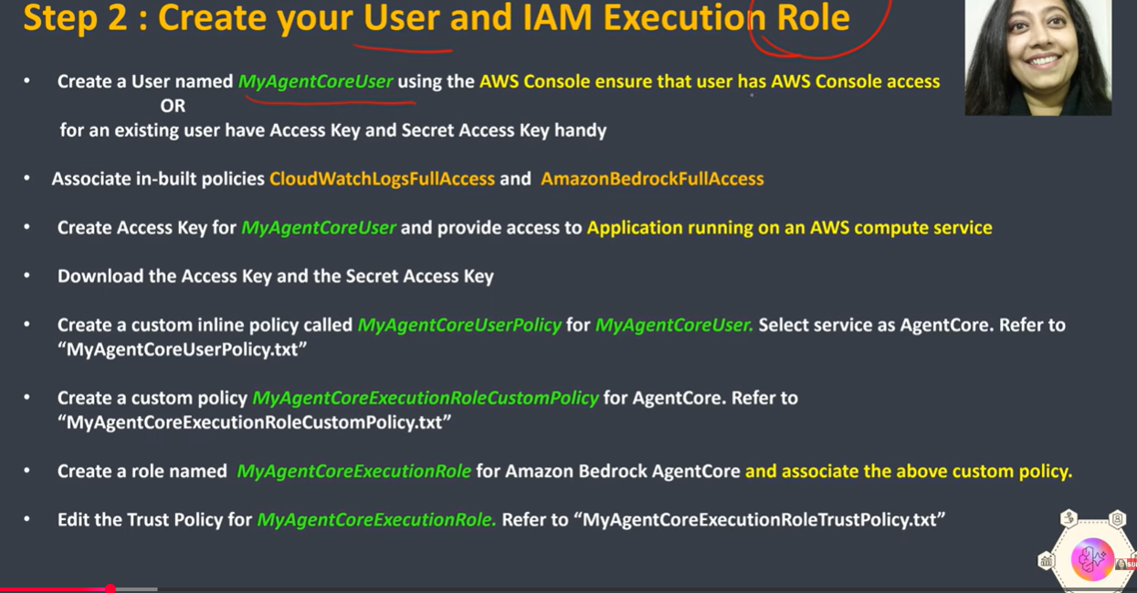

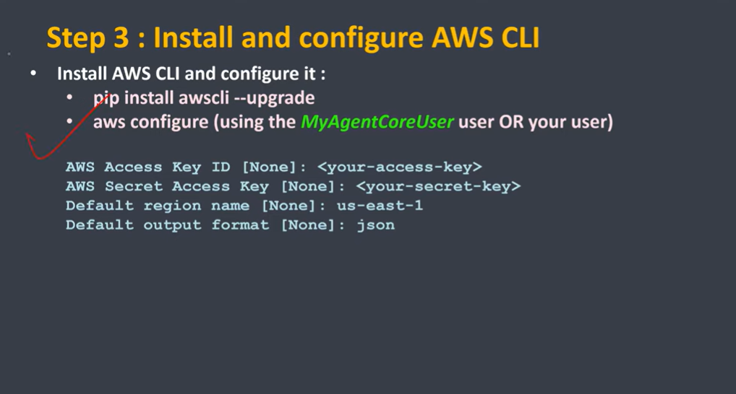

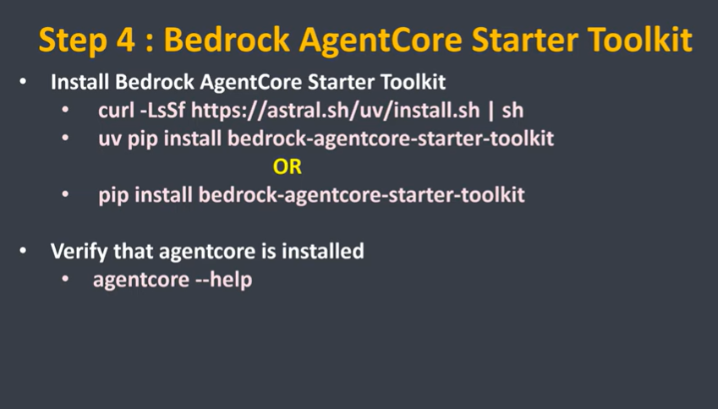

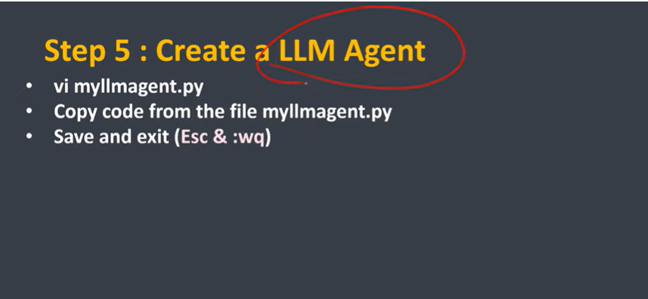

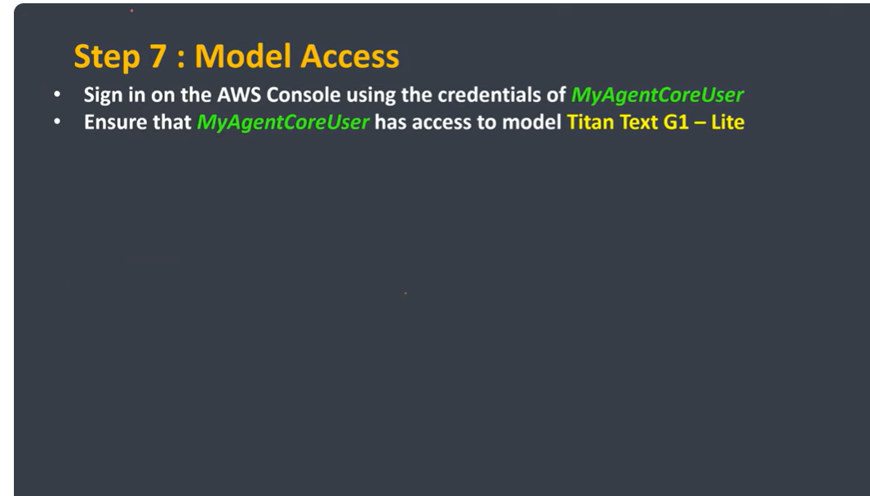

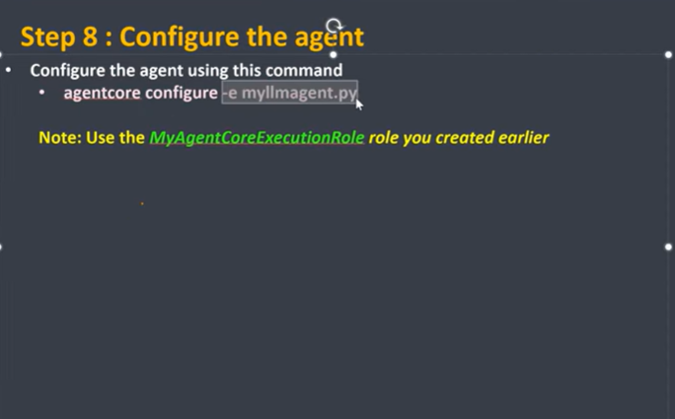

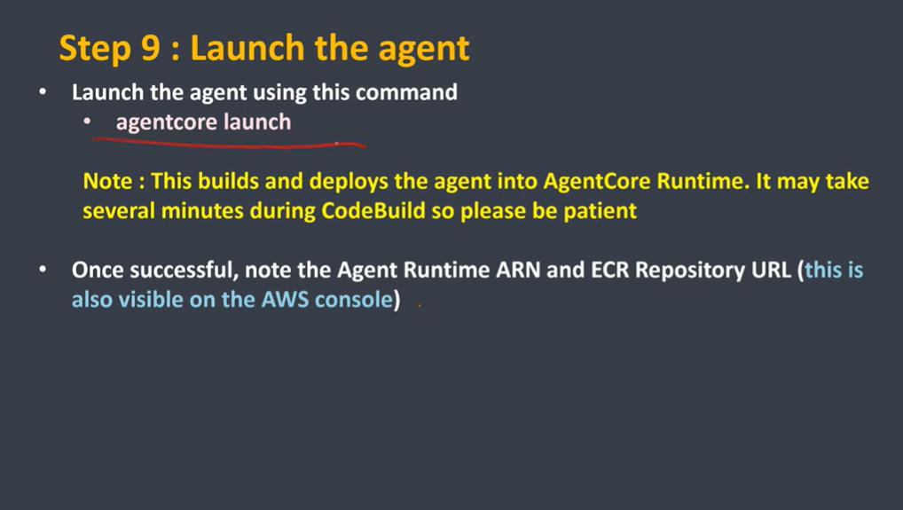

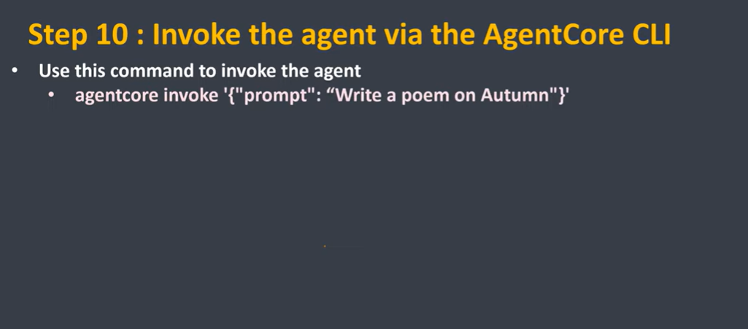

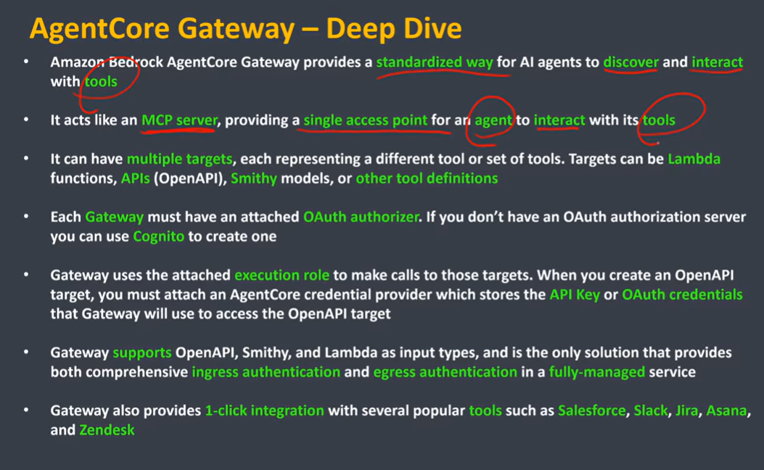

Amazon Bedrock AgentCore Gateway - Complete Notes
1. What is Amazon Bedrock AgentCore Gateway?
Amazon Bedrock AgentCore Gateway is a managed service that acts as a secure bridge between an AI agent and external tools, APIs, databases, or enterprise services. Instead of allowing the LLM to directly invoke external systems, the gateway manages tool discovery, authentication, authorization, routing, and secure execution. It centralizes tool access, making AI applications easier to secure, monitor, and scale.

2. Why do we need AgentCore Gateway?
Without a gateway, every AI application would have to implement authentication, API integration, retries, routing, logging, and security individually. AgentCore Gateway removes this complexity by providing a centralized layer where tools are registered once and securely accessed by multiple agents. This improves maintainability, governance, and consistency across production AI applications.

3. Difference Between API Gateway and AgentCore Gateway
API Gateway is designed for client applications such as web or mobile apps. It receives HTTP requests and forwards them to backend services like Lambda, ECS, or EC2. AgentCore Gateway is completely different. It is designed for AI agents and manages communication between the agent and external tools. It does not replace API Gateway; both often work together.
Example:
User
│
API Gateway
│
Application
│
Bedrock Agent
│
AgentCore Gateway
│
External APIs

4. What Happens When a User Sends a Prompt?
When a user sends a prompt such as "Check my bank balance," the Bedrock Agent first analyzes the request. If the task requires an external tool, the agent invokes AgentCore Gateway. The gateway authenticates the request, selects the appropriate registered tool, executes the API call, receives the response, and returns the result back to the agent for final natural language generation.

5. Debugging Messages
Debugging Messages provide developers with detailed error information during development and testing. Instead of returning a generic "Internal Server Error," the gateway returns information such as authentication failures, missing parameters, invalid payloads, request identifiers, execution time, and tool-level failures. These messages significantly simplify troubleshooting but should generally be disabled in production environments for security reasons.
Example:
Without Debugging
500 Internal Server Error
With Debugging
Authentication Failed
Missing API Key
Tool Name: Weather API
Request ID: xxxx

6. Why Should Debugging Be Disabled in Production?
Detailed debugging information may expose sensitive implementation details including internal API names, server paths, authentication methods, stack traces, or infrastructure components. Attackers can use this information to understand system architecture. Therefore, production systems typically return only generic error messages while detailed logs remain accessible only to developers through monitoring services like CloudWatch.

7. Custom Encryption
AgentCore Gateway supports custom encryption using AWS Key Management Service (KMS). By default, AWS encrypts gateway resources using AWS-managed keys. Organizations handling sensitive workloads such as banking, healthcare, or government applications often prefer Customer Managed Keys (CMKs), allowing complete control over key rotation, auditing, permissions, and compliance requirements.

8. What Exactly Does KMS Encrypt?
This is the most misunderstood concept.
KMS does NOT encrypt user prompts.
It encrypts stored gateway resources, including:
- Tool configuration
- API credentials
- OAuth tokens
- API Keys
- Authentication secrets
- Connection strings
- Gateway metadata
- Stored configuration
Example
Gateway Configuration

API URL
API Secret
OAuth Token

↓

KMS Encryption

↓

Encrypted Storage

9. Does KMS Encrypt User Messages?
No.
User prompts travel over HTTPS/TLS encryption.
Example
User

↓

HTTPS

↓

Gateway
This network encryption is completely different from KMS encryption.
KMS only encrypts data stored inside AWS.

10. What Happens During Decryption?
Suppose a tool requires an API Key.
The gateway retrieves the encrypted API Key from storage.
Encrypted API Key

↓

KMS

↓

Original API Key

↓

Tool Invocation
Only services or roles with proper KMS permissions can request decryption.

11. AWS Managed Key
AWS Managed Keys are created and managed entirely by AWS. Customers do not control key rotation, lifecycle, or permissions beyond basic usage. These keys are suitable for most workloads because AWS automatically handles creation, storage, rotation, availability, durability, and maintenance without requiring administrative effort.

12. Customer Managed Key (CMK)
Customer Managed Keys are created inside AWS KMS by customers. Organizations control who can use the key, when it rotates, whether it is disabled, deleted, or audited. CMKs are preferred in regulated industries where compliance requires customer ownership and management of encryption keys.

13. How to Create a Customer Managed Key
Open AWS Console → Key Management Service → Customer Managed Keys → Create Key. Choose a Symmetric key, select Encrypt/Decrypt usage, provide an alias and description, assign IAM administrators and key users, then create the key. During AgentCore Gateway creation, choose this key instead of the default AWS-managed key.

14. IAM User
An IAM User represents a human identity. It has a username, password, and optionally access keys for CLI or SDK access. IAM Users are generally used by administrators, developers, or operators who manually interact with AWS resources through the console or programmatic APIs.

15. IAM Role
IAM Roles are permission containers used by AWS services, applications, EC2 instances, Lambda functions, ECS tasks, and Bedrock Agents. Roles have no passwords or permanent credentials. Instead, AWS services temporarily assume roles whenever they need permission to access AWS resources.

16. Why Do We Prefer IAM Roles?
Production applications should never store permanent AWS credentials inside source code. Instead, applications assume IAM Roles and automatically receive temporary credentials. This approach eliminates credential leakage, simplifies rotation, improves security, and follows AWS best practices for least privilege access.

17. What is AWS STS?
AWS Security Token Service (STS) generates temporary security credentials after an IAM Role is assumed. These credentials include an Access Key, Secret Key, and Session Token that automatically expire after a configurable duration. Temporary credentials are significantly more secure than permanent access keys.
Flow
IAM Role

↓

STS

↓

Temporary Credentials

↓

AWS Services

18. Relationship Between IAM Role, STS, and KMS
These services work together.
Bedrock Agent

↓

IAM Role

↓

STS

↓

Temporary Credentials

↓

KMS

↓

Decrypt API Secret

↓

Call External API
IAM Role defines permissions.
STS provides temporary credentials.
KMS performs encryption and decryption.

19. Semantic Search of Tools
Semantic Search allows AgentCore Gateway to discover tools based on user intent rather than exact tool names. Instead of matching keywords, the gateway uses semantic understanding to identify the most relevant tool, improving tool selection accuracy and reducing dependency on exact naming conventions.
Example
User

"I need today's temperature."

↓

Gateway

↓

Weather Tool

20. Tagging
Tags are metadata labels attached to gateway resources. They help organize environments, identify owners, allocate cloud costs, automate deployments, apply governance policies, and simplify operational management. Production systems should consistently tag every gateway using project, environment, owner, application, and cost center information.
Example
Project=AI

Environment=Production

Owner=Suraj

CostCenter=101

21. Required IAM Permissions for AgentCore Gateway
If AgentCore Gateway uses a Customer Managed KMS Key, its execution role generally requires these KMS permissions:
kms:Encrypt
kms:Decrypt
kms:GenerateDataKey
kms:DescribeKey
Explanation:
- kms:Encrypt – Encrypt gateway configuration before storing it.
- kms:Decrypt – Decrypt stored secrets when the gateway needs them.
- kms:GenerateDataKey – Generate temporary data encryption keys (used internally by envelope encryption).
- kms:DescribeKey – Read key metadata and verify key availability.
Apply the principle of least privilege. Grant only the permissions actually required by the gateway.

22. When Should These Permissions Be Configured?
Configure these permissions before deploying the AgentCore Gateway if you plan to use a Customer Managed KMS Key.
Typical deployment order:
- Create the KMS Key.
- Create the IAM Execution Role.
- Attach KMS permissions to the role.
- Allow the role in the KMS Key Policy (or grants).
- Create the AgentCore Gateway.
- Select the Customer Managed Key.
- Register tools and configure authentication.
If the role lacks KMS permissions, the gateway won't be able to encrypt or decrypt its stored secrets.

23. Production Architecture
User
│
HTTPS Request
│
API Gateway
│
FastAPI/Lambda
│
Bedrock Agent
│
AgentCore Gateway
│
┌───────────────┼───────────────┐
│ │ │
Weather API Bank API CRM API
│ │ │
└───────────────┼───────────────┘
│
KMS (Secrets)
│
Encrypted Gateway Configuration

Interview Summary
- API Gateway → Client to backend communication.
- AgentCore Gateway → Agent to tools communication.
- KMS → Encrypts stored gateway configuration, secrets, tokens, and API credentials.
- HTTPS/TLS → Protects data while it travels across the network.
- IAM Role → Permissions assigned to AWS services.
- STS → Issues temporary credentials after assuming a role.
- AWS Managed Key → Fully managed by AWS.
- Customer Managed Key → Fully controlled by the customer.
- Semantic Search → Finds tools based on intent instead of exact names.
- Debugging → Enable during development; disable in production.
- Tagging → Used for organization, governance, billing, and automation.
These notes reflect production practices and align with how AWS recommends securing and operating

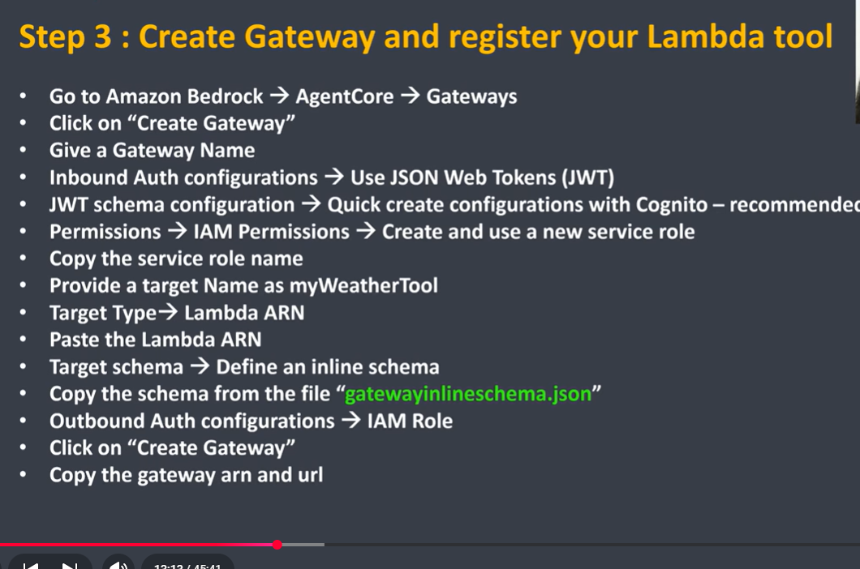

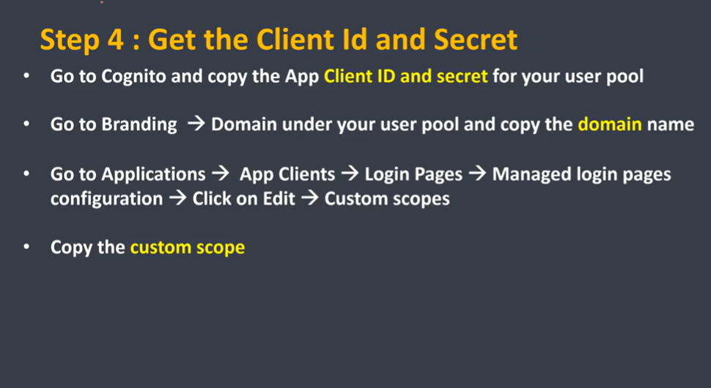

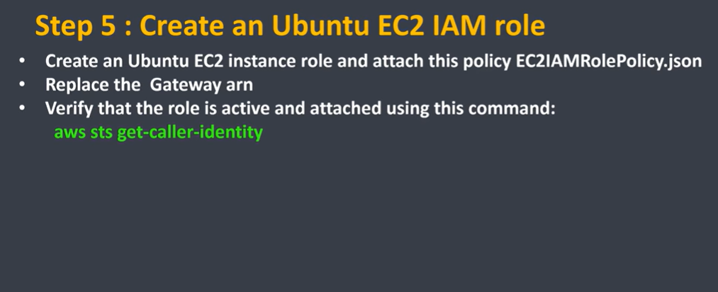

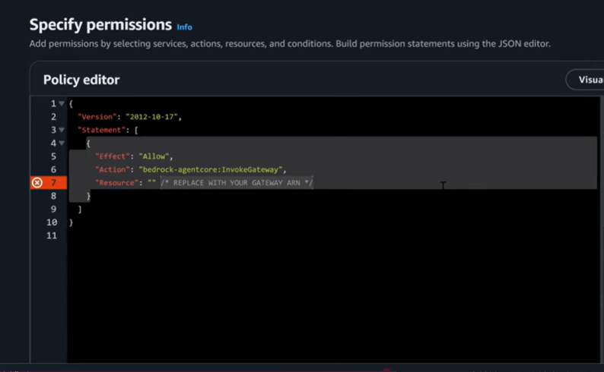

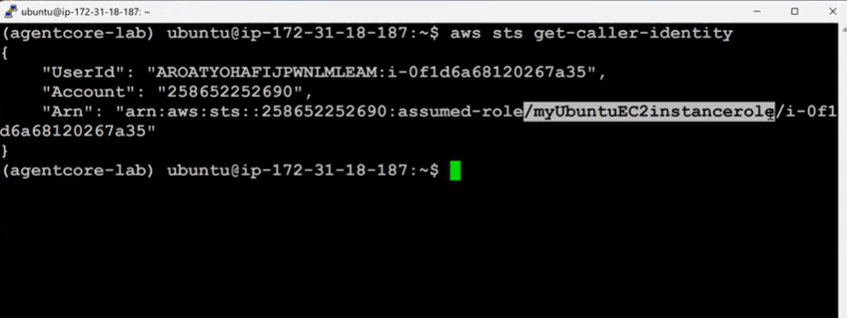

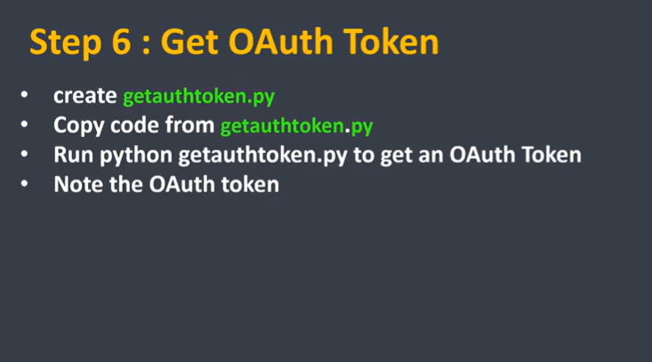

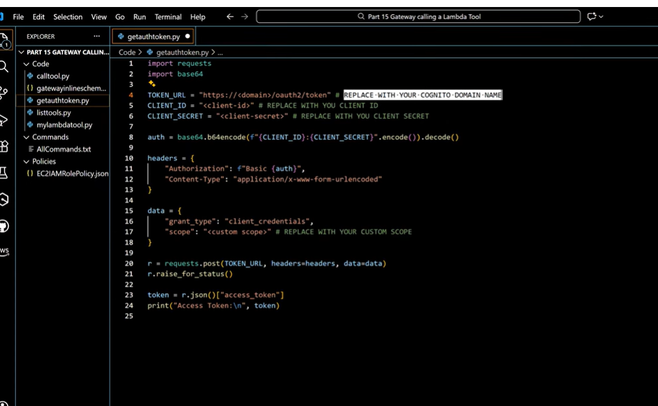

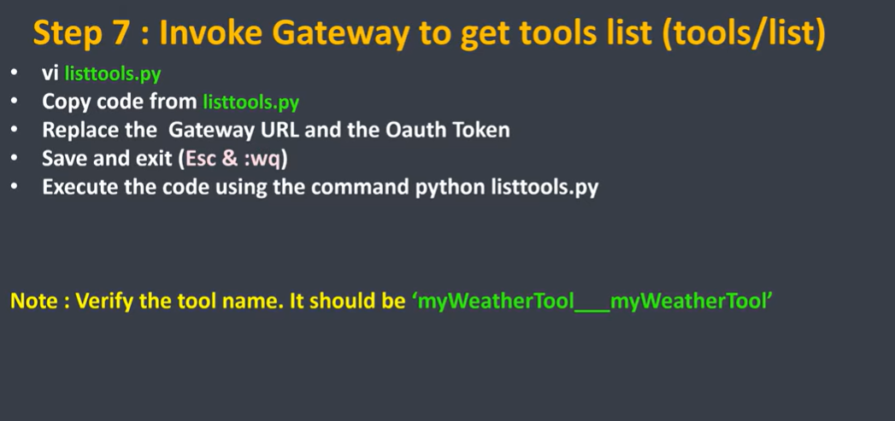

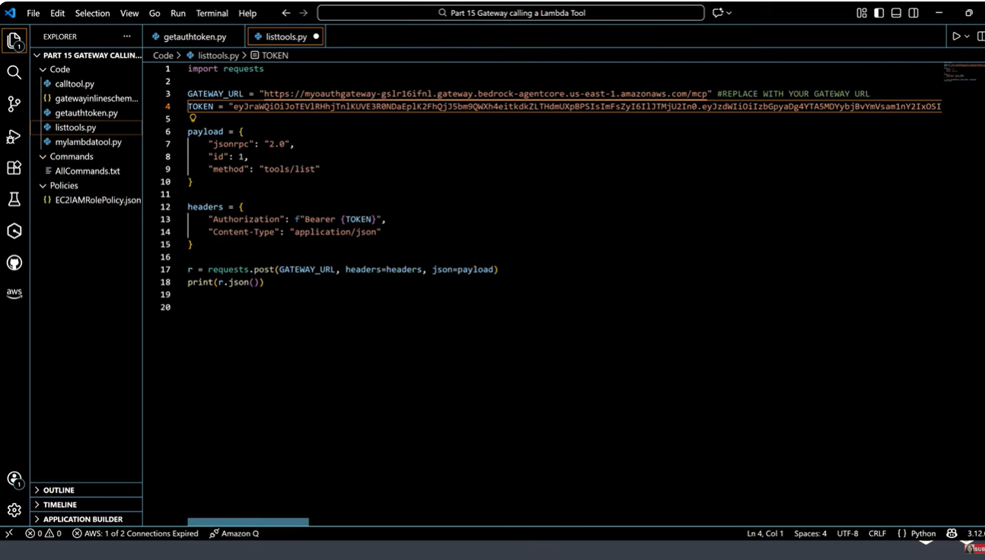

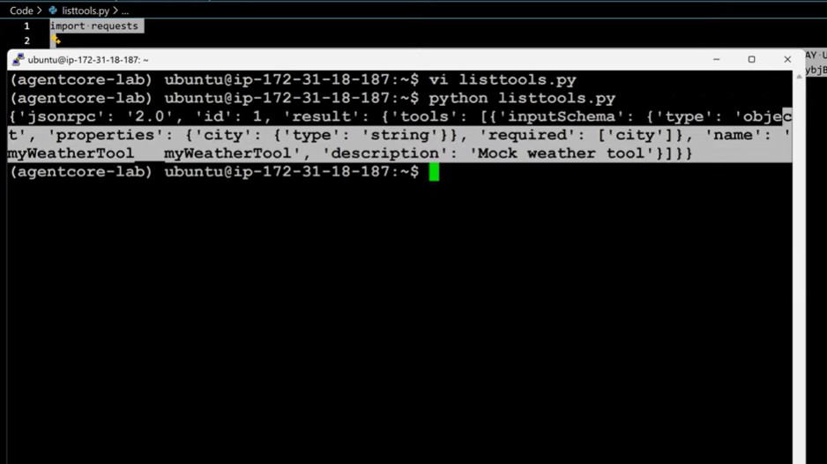

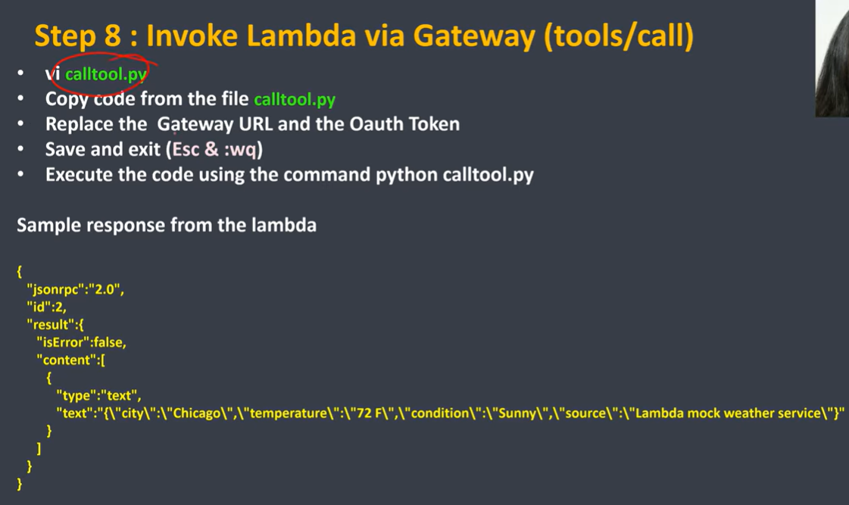

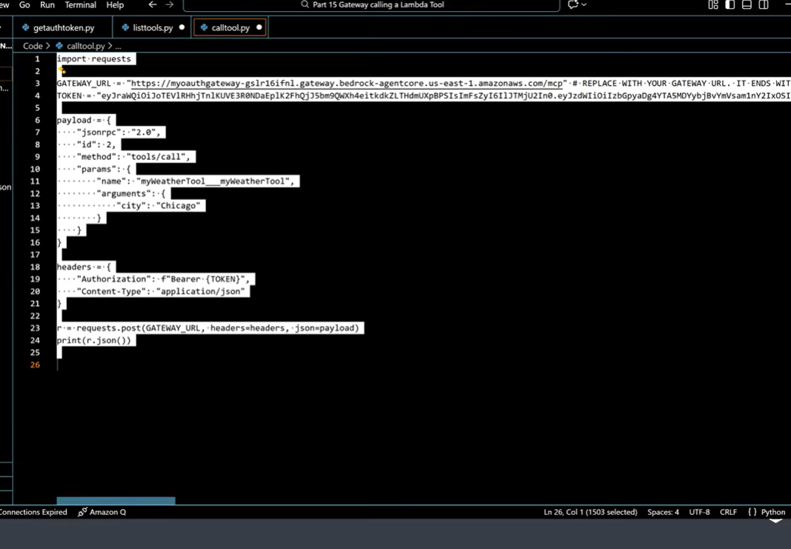

In One Line
- Gateway = Calls the tool.
- Policy = Checks whether the tool call is allowed.
Real-Life Example
Suppose your AI is a Banking Agent.
The user says:
"Show me Rahul Sharma's account balance."
If there is no policy, the agent directly calls the Bank Tool.
User
│
▼
Agent
│
▼
Gateway
│
▼
Bank API
This is dangerous.
Now, let's add a Policy.
User
│
▼
Agent
│
▼
Gateway
│
▼
Policy Engine
│
├── Allowed? → Yes → Bank API
│
└── Denied? → Stop Here
Now, before every tool call, the agent checks for permission. This is the core idea of the entire slide.

1. AgentCore Policy enables developers to define and enforce security controls...
This is the most important sentence on the slide.
It means that AgentCore Policy provides developers with a central place to define security rules. An AI agent is intelligent, but not every intelligent decision is safe. The agent might accidentally call a sensitive tool or expose confidential data.
A policy creates a protective boundary between the agent and external tools. Whenever the agent invokes a tool through the Gateway, the policy evaluates the request. If the request complies with the organization's security rules, the Gateway executes the tool. Otherwise, the request is rejected.
The biggest advantage is that security logic is not hardcoded into the agent's code. Instead, it is managed centrally.

2. Developers can create policy engines, create and store deterministic policies, and associate policy engines with gateways.
This introduces three new concepts:
- Policy Engine
- Deterministic Policy
- Associate with Gateway
A Policy Engine is the runtime component that executes policies. It stores multiple security rules.
A Deterministic Policy means that the same input always produces the same result. For example, if the rule says:
"Intern users cannot access the Bank Tool."
Then every time an intern makes that request, the result will always be DENY. There is no AI reasoning or guessing involved.
The Policy Engine is then attached to the Gateway. Whenever the Gateway receives a tool call request, it first asks the Policy Engine for permission.
Depending on the architecture, a Gateway can be associated with one or multiple Policy Engines.

3. Policy intercepts all agent traffic through AgentCore Gateways and evaluates each request before allowing tool access.
This is the heart of production security.
Intercept means stopping the request in the middle before it reaches the tool.
When the Agent tells the Gateway:
"Call the Bank Tool."
The Gateway does not execute the tool immediately.
Instead, the request is first sent to the Policy Engine, which checks:
- Who is the user?
- Which tool is being called?
- What parameters are being passed?
- Is this operation allowed?
If all conditions are satisfied, the Gateway executes the tool.
If even one policy check fails, the Gateway rejects the request immediately.
This process prevents:
- Unauthorized tool access
- Sensitive operations by unauthorized users
- Accidental data leaks

4. Policies are constructed using Cedar.
Cedar is AWS's open-source authorization policy language.
Just as SQL is used for databases, Cedar is used for writing authorization rules.
With Cedar, you can define:
- Who the user is
- Which resource they can access
- Which actions they are allowed to perform
- Under what conditions access is allowed or denied
Example concepts:
Allow Employee
to use the Weather Tool
Deny Guest
to use the Bank Tool
The Policy Engine evaluates the Cedar policy and returns the final decision.
Because Cedar is deterministic, security decisions remain predictable, consistent, and auditable.

5. Policy provides the capability to author policies using natural language...
This feature improves the developer experience.
Not every developer knows Cedar syntax.
Therefore, AgentCore allows developers to write policies in natural language.
For example:
"Only Managers can access the Payroll Tool."
The system can convert this English sentence into a Cedar policy.
This does not mean that the runtime evaluates English directly.
At runtime, the system always executes the compiled Cedar policy.
Natural language is only used to make policy authoring easier, especially for teams that are not security experts.

6. Policy supports fine-grained permissions based on user identity and tool input parameters.
This is an enterprise-level feature.
Fine-grained permission means that authorization is not limited to simply deciding whether someone can use a tool.
Instead, it also decides under what conditions they can use it.
Examples:
- An employee can view only their own salary record.
- HR can view every employee's salary.
- A manager can view only the data of their own team.
Here, the policy checks not only the user's identity but also the tool's input parameters.
For example, if the tool receives:
account_id = 12345
The policy verifies whether the logged-in user is authorized to access that specific account.
This enables parameter-level authorization.

7. By moving security controls outside of agent code...
This follows a software engineering best practice.
If every security rule is written directly into the agent's Python code, then every new rule requires:
- Code changes
- Testing
- Redeployment
AgentCore Policy separates security from business logic.
The agent focuses only on business operations, while the Policy Engine handles all security decisions.
This makes maintenance easier, allows security teams to update policies independently, and removes the need for developers to modify code for every security change.
In enterprise environments, this separation of concerns makes systems more secure, scalable, and easier to manage.

The Entire Slide in One Diagram
User
│
▼
Agent
│
▼
Gateway
│
▼
Policy Engine
│
├── Allow ──► Tool
│
└── Deny ──► Request Blocked
Easy Formula to Remember
- Agent → Decides which tool is needed.
- Gateway → Invokes (calls) the tool.
- Policy Engine → Decides whether the tool invocation is permitted.
- Cedar → The language used to write those security rules.

